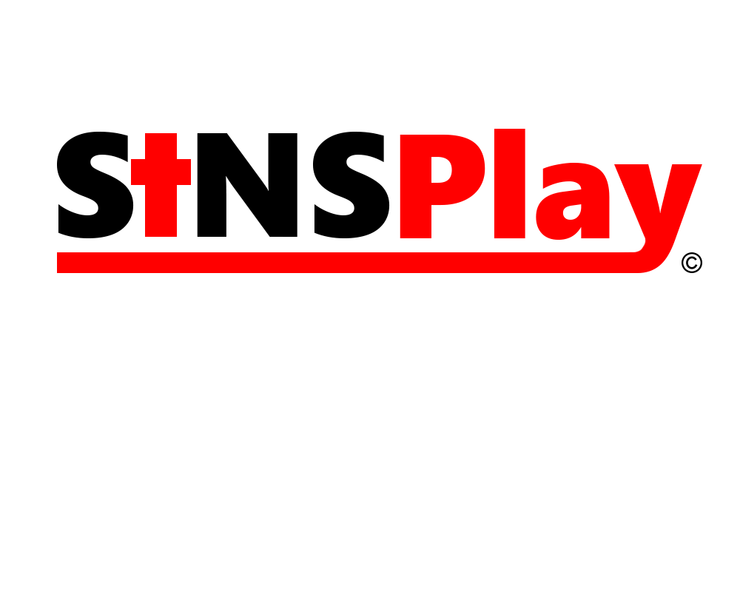

**Sins.**

Product Owner - Timothy Tanchanco,

Scrum Master - Dillon Hour

Sins. is a 2D Side Scrolling Action Role Playing Game that aims towards the player to get them more engaged with the gameplay. Throughout your quest, you are given special abilities and weapons to fight off anything that gets in your way. The story of the game will be reflected on the seven deadly sins; Wrath, Lust, Gluttony, Greed, Sloth, Envy, and Pride. As the player advances through the levels, they will have a chance to make decisions based on the scenarios given throughout their journeys. The players decisions will ultimately affect the outcome of the game. One decision that has to be made is once the player defeats one of the deadly sins, he/her will have the option of joining forces with that sin or destroying it. The difficulty of the game will scale as you play through the game; however, the choices you make will also affect the difficulty of the game. You will be able to level up your character, increase your abilities and weapons, and unlock other characters to help you along the journey.

If there are players that want to play with another person, there will be an option for a multi player co-op mode for the story. However, instead of going on the conquest and making decisions alone, you will be alongside your partner defeating or joining forces with the deadly sins.

If that wasn’t enough, there will also be a multiplayer versus mode where you can test your skills against other players online. In this game mode, players from all around the world can join and show off their skills. Players will have the chance to face one on one matches with each other. To make battles fair, players will be matched by ranks and level. Therefore, one player cannot have a better advantage than another player.